**1. Consumer Financial Protection Bureau (CFPB):**

### 2. Anti-Money Laundering (AML) Regulations:

### 3. Know Your Consumer (KYC) Regulations:

**(Presented By Alan Stuart K)**

**1. Consumer Financial Protection Bureau (CFPB):**

**Introduction:**

The Consumer Financial Protection Bureau (CFPB) is a regulatory agency established in 2010 under the Dodd-Frank Wall Street Reform and Consumer Protection Act. Its primary mission is to protect consumers in the financial marketplace by enforcing federal consumer financial laws and promoting fair practices. The CFPB oversees a wide range of financial products and services, including mortgages, credit cards, and student loans.

**Terminologies:**

* **Consumer Complaint:** A formal statement by a consumer expressing dissatisfaction with a financial product or service.
* **Regulatory Agency:** A government body responsible for enforcing laws and regulations within a specific industry.
* **Financial Product:** Any product offered by a financial institution, such as loans, credit cards, and bank accounts.
* **Consumer Protection:** Measures and regulations to safeguard consumers from unfair, deceptive, or abusive practices by businesses.
* **Resolution Time:** The amount of time it takes to address and resolve a consumer complaint.
* **Consumer Financial Protection:** Efforts and regulations to ensure fair treatment of consumers in the financial marketplace.
* **Regulation:** Rules established by authorities to govern the behaviour of individuals and organizations.
* **Complaint Database:** A repository where consumer complaints are stored and analysed for trends and issues.
* **Remediation:** Actions taken to correct issues identified in consumer complaints or regulatory examinations.
* **Supervision:** The process by which regulatory agencies oversee financial institutions to ensure compliance with laws and regulations

**Graphs:**

**Graph 1.A:** CFPB Consumer Complaints Over Time:

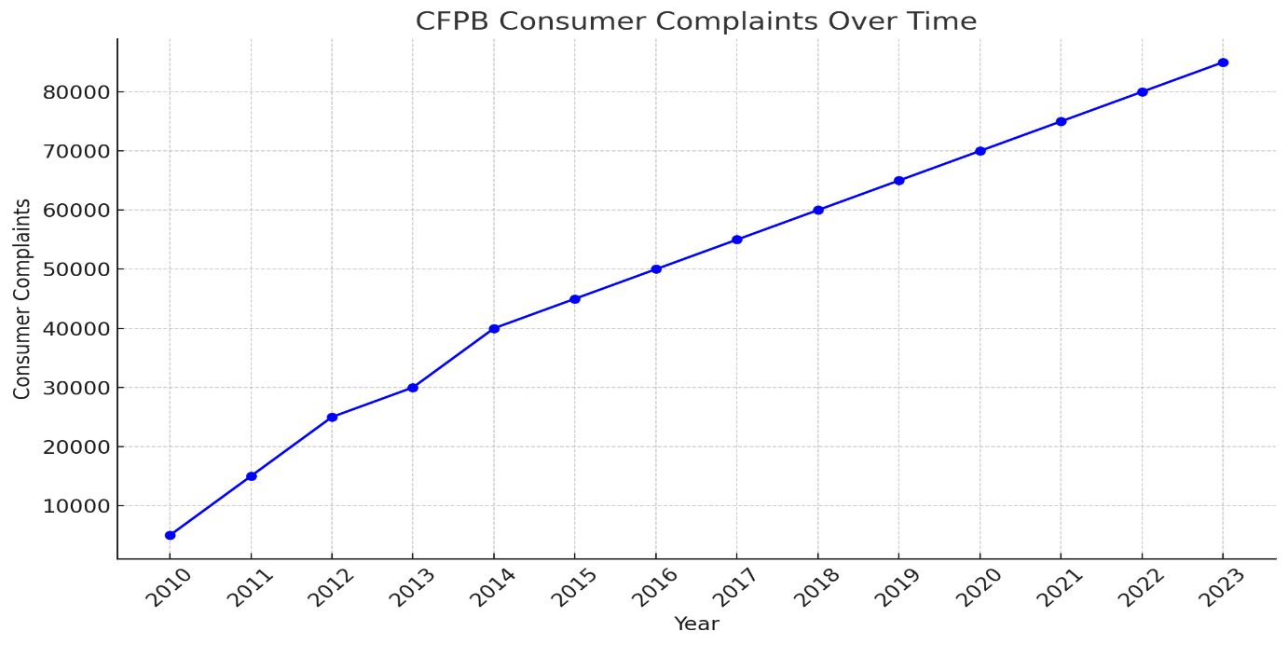**Inference:**

* **Steady Increase in Complaints:** The graph shows a clear and steady increase in the number of consumer complaints over the years, rising from 5,000 in 2010 to 85,000 in 2023.
* **Impact of Regulation and Awareness:** This increase may be attributed to heightened consumer awareness, increased access to complaint mechanisms, and possibly more aggressive marketing and service practices by financial institutions.
* **Regulatory Response:** The growing number of complaints could prompt the CFPB to strengthen its regulatory actions, improve consumer protection measures, and ensure more stringent compliance from financial institutions.

**Graph 1.B:** CFPB Consumer Complaints by Type in 2023:

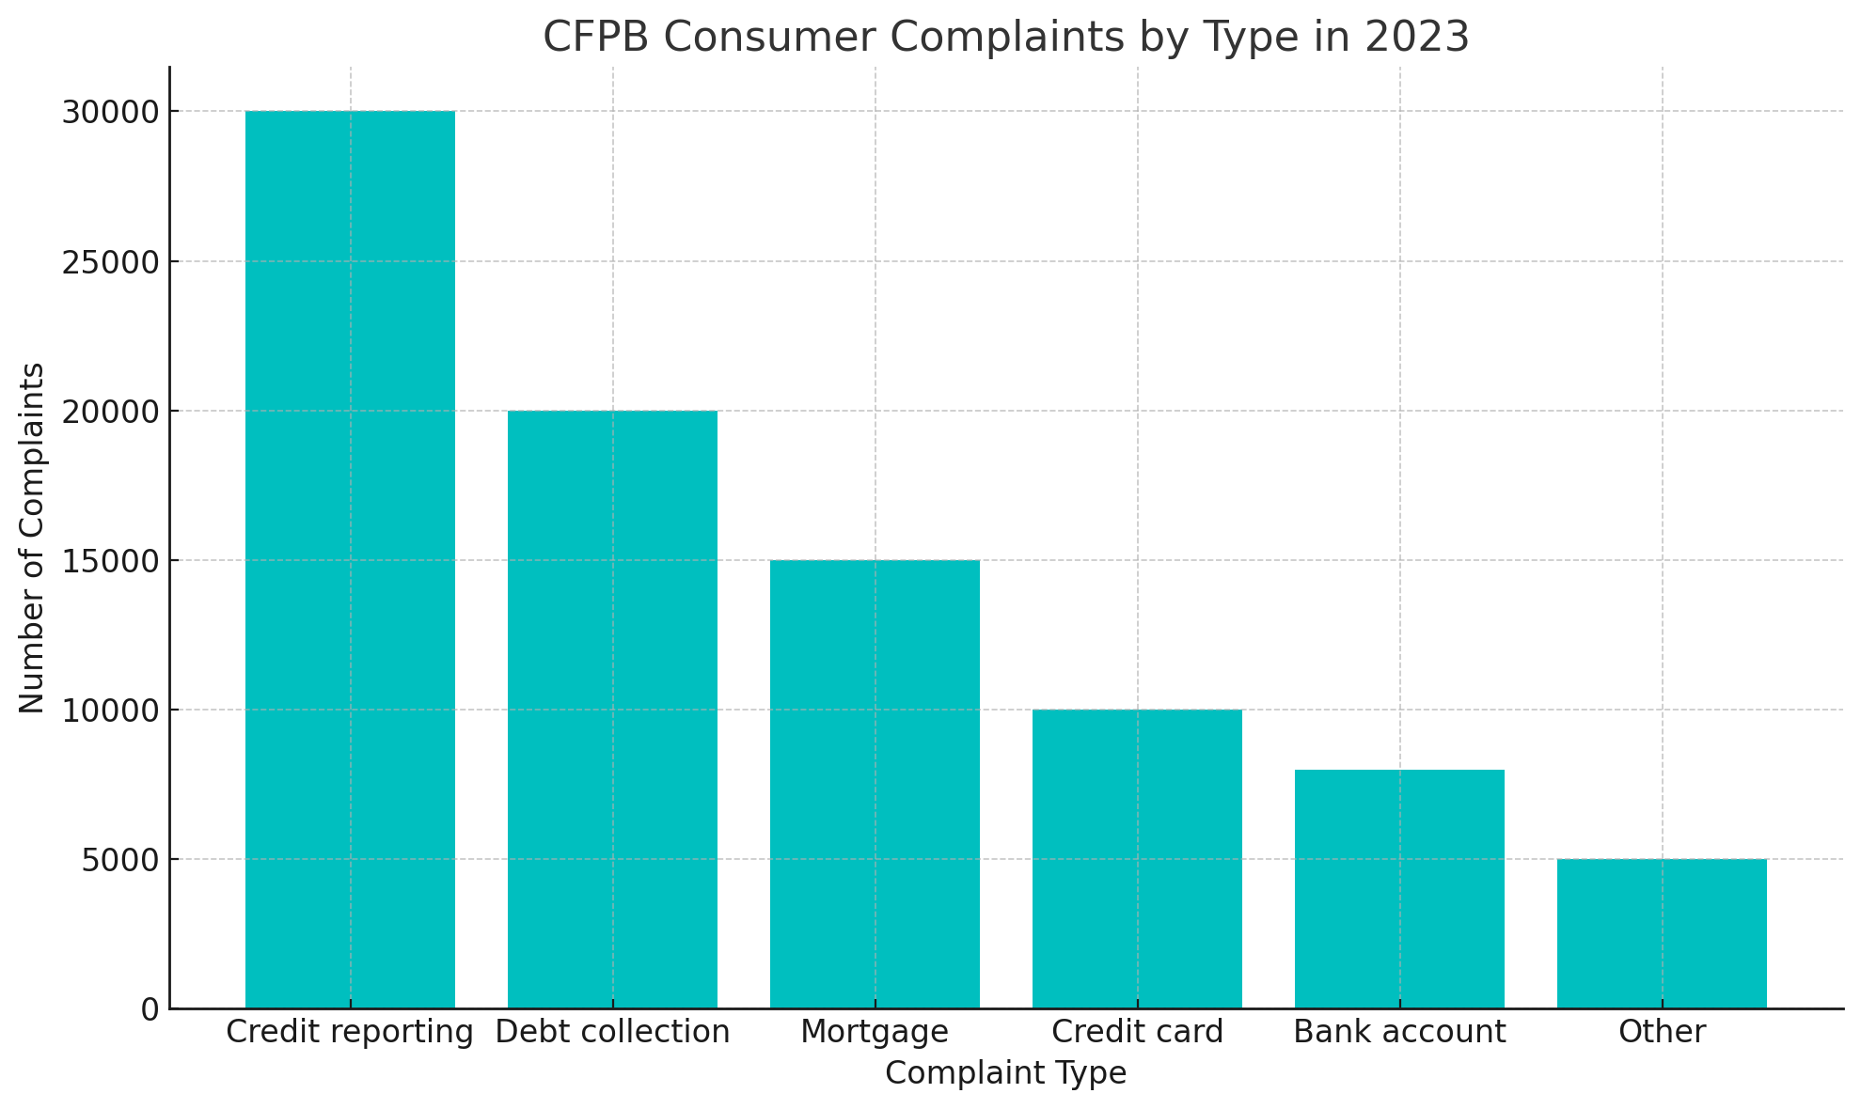**Inference:**

* **Major Complaint Areas:** Credit reporting, debt collection, and mortgage issues are the most common complaints. This indicates specific areas where consumers face significant challenges and where regulatory interventions may be particularly needed.
* **Targeted Improvements:** Financial institutions might focus on improving transparency, accuracy, and fairness in these areas to reduce complaints and enhance consumer satisfaction.

### 2. Anti-Money Laundering (AML) Regulations:

#### Introduction:

Anti-Money Laundering (AML) regulations are designed to prevent and detect money laundering activities, where illegally obtained funds are made to appear legitimate. These regulations require financial institutions to implement robust systems and processes to identify and report suspicious activities. Key components of AML regulations include customer due diligence (CDD), suspicious activity reporting (SAR), and ongoing monitoring.

**Terminologies:**

* **Money Laundering:** The process of concealing the origins of money obtained illegally by passing it through a complex sequence of banking transfers or commercial transactions.
* **AML Compliance:** Adherence to laws and regulations designed to prevent money laundering.
* **Suspicious Activity Report (SAR):** A document that financial institutions must file with regulators to report suspicious activity that might indicate money laundering or fraud.
* **Know Your Customer (KYC):** A process used by financial institutions to verify the identity of their clients and assess potential risks of illegal intentions.
* **Penalties:** Fines or sanctions imposed on financial institutions for failing to comply with AML regulations.
* **Beneficial Owner:** The person or entity that ultimately owns or controls a financial account or transaction.
* **Risk Assessment:** The process of identifying and evaluating potential risks of money laundering within an institution.
* **Customer Risk Profile:** An evaluation of the risk level of a customer based on factors such as transaction behavior and geographic location.
* **Transaction Monitoring:** The automated process of reviewing financial transactions to detect suspicious activity.
* **Compliance Officer:** An individual responsible for ensuring that a financial institution adheres to regulatory requirements.
* **Financial Action Task Force (FATF):** An international organization that sets standards and promotes effective implementation of legal, regulatory, and operational measures to combat money laundering and terrorist financing.

**Graphs:**

**Graph 2.A:** AML Compliance Costs Over Time:

### Inference:

* **Rising Compliance Costs:** The data shows a consistent increase in AML compliance costs, from $1.5 billion in 2010 to $4.3 billion in 2023.
* **Increasing Regulatory Demands:** The rising costs reflect the increasing complexity and demands of AML regulations. Financial institutions need to invest more in sophisticated technology, skilled personnel, and enhanced processes to comply with these regulations.
* **Impact on Financial Institutions:** While the investment in AML compliance is crucial for preventing financial crimes, the rising costs also indicate a significant financial burden on institutions, which could affect their profitability and resource allocation.

**Graph 2.B:** Number of AML Investigations Over Time:

### Inference:

* **Growing Number of Investigations:** The increase from 1,000 AML investigations in 2010 to 2,300 in 2023 highlights a more proactive stance by regulators in identifying and addressing money laundering activities.
* **Regulatory Focus:** This trend suggests an increasing emphasis on monitoring and enforcement, which may deter financial crimes but also increase the regulatory burden on institutions.

### 3. Know Your Consumer (KYC) Regulations:

#### Introduction:

Know Your Customer (KYC) regulations mandate that financial institutions verify the identity of their customers to prevent fraud, money laundering, and terrorist financing. KYC processes involve collecting and verifying personal information, assessing risk, and monitoring transactions. These regulations are critical for maintaining the integrity of the financial system.

**Terminologies:**

* **Customer Due Diligence (CDD):** The process of collecting and evaluating customer information to verify their identity and assess risk.
* **Enhanced Due Diligence (EDD):** Additional measures taken for high-risk customers to gather more detailed information and conduct ongoing monitoring.
* **Customer Identification Program (CIP):** A requirement for financial institutions to verify the identity of individuals wishing to conduct financial transactions.
* **Compliance Costs:** Expenses incurred by financial institutions to adhere to regulatory requirements.
* **Verification Methods:** Different techniques used to verify customer identity, including in-person, online, and hybrid methods.
* **Onboarding:** The process of integrating a new customer into a financial institution's system, including verifying their identity and risk assessment.
* **Ongoing Monitoring:** Continuous review of customer transactions and behaviour to detect and prevent illicit activities.
* **Identity Verification:** The process of confirming that a person is who they claim to be using documents or digital tools.
* **Data Privacy:** The practice of protecting customer information from unauthorized access and ensuring it is used appropriately.
* **Regulatory Technology (Reg-Tech):** The use of technology to help financial institutions comply with regulations more efficiently.

**Graphs:**

**Graph 3.A:** KYC Compliance Costs and Fines Over Time:

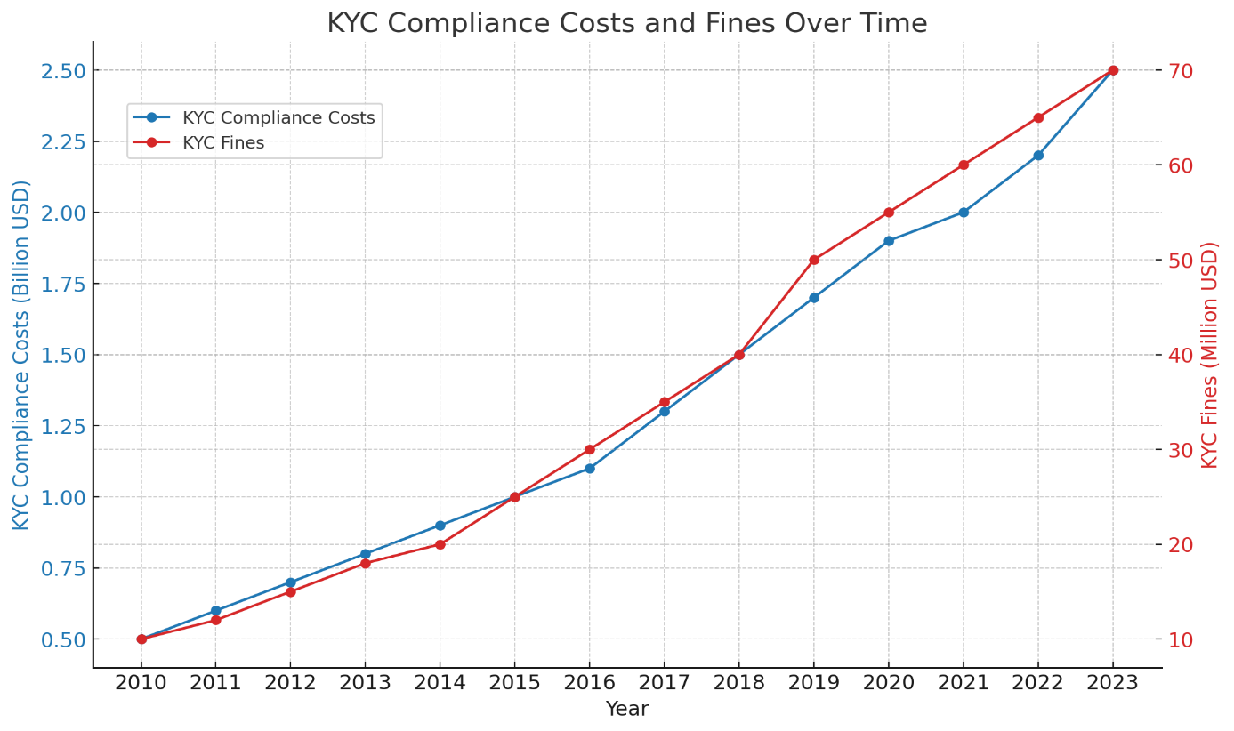**Inference:**

* **Increase in Compliance Costs:** KYC compliance costs have risen from $0.5 billion in 2010 to $2.5 billion in 2023, highlighting the growing investment required for effective customer verification processes.
* **Rising Fines:** The increase in fines from $10 million in 2010 to $70 million in 2023 suggests stricter enforcement and higher penalties for non-compliance. This indicates a regulatory environment that is increasingly intolerant of lapses in KYC processes.
* **Dual Impact:** The dual increase in compliance costs and fines emphasizes the need for financial institutions to prioritize KYC compliance to avoid substantial penalties, while also investing in effective KYC systems to meet regulatory standards.

**Graph 3.B:** KYC Verification Methods in 2023:

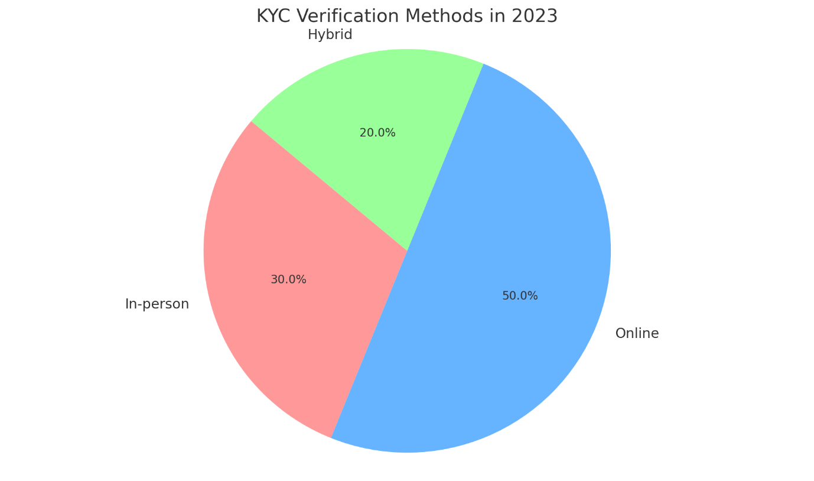**Inference:**

* **Shift to Digital Verification:** Online KYC methods dominate, reflecting the banking sector's move towards digital solutions to enhance efficiency and customer experience.
* **Hybrid Approach:** The presence of hybrid methods indicates that while digital solutions are on the rise, a combination of in-person and online methods is still necessary to meet diverse customer needs and regulatory requirements.

### Conclusion:

The US banking sector is subject to stringent regulatory oversight to protect consumers and ensure the integrity of the financial system. Agencies like the CFPB, and regulations such as AML and KYC, play vital roles in maintaining this oversight. Understanding the trends and challenges in these areas helps financial institutions navigate the regulatory landscape effectively while safeguarding consumer interests and maintaining compliance.